Micro Muncher Hydroponics 1sq. Ft.
Concept Objective: Food Sustainability
Time: 40-45 minutes
Setting: Indoors
Align with NGSS – Life & Phys. Science – and Alaska Cultural Standards
Activities:
Construct Micro Munch 1FT. Hydroponic System for growing lettuce
Construction Materials Needed:
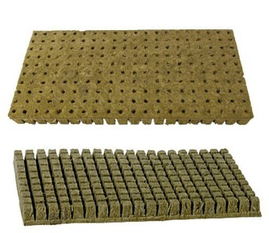
Note –The below information is for one Micro Munch unit; for classrooms with enough space, it is encouraged to have each table group construct a unit.
- Rubbermaid Tote –shoe box size
- Clay hydroponic media pebbles – For plant suspension and support
- Rockwool - 2 one inch cubes- and two 2-inch nesting rock wool cubes
- Large air stone (fish aquarium bubbler 4-6 inches)
- Aquarium air pump/compressor for 5-15 gallons (one pump can run up 1 inch Rockwool
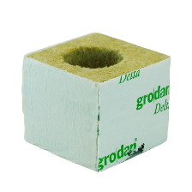
to 2 units)
- 8 ft. of standard airline tubing (2.44 M)
- 1 Check valve – to prevent water backflow to the air pump
- lighting – 2 ft LED grow light or square small dot LED system.
- Two 2-inch hydroponic net pots Nesting Rock Wool
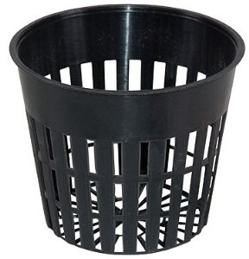
Equipment list
- Scissors to cut airline tubing.
- Timer for the LED light (Northern latitudes operate lighting for 18 hour per day)
- Liquid Microbes- nutrients for leafy green vegetables
- Liquid fertilizer - nutrients for leafy green/ vegetables Net Pot
Discussion how the Micro Munch System works.
Hydroponics systems have been around for decades. Conservationists and horticulturists have experimented with many different methods of hydroponics over the past century. The Micro Munch was created out of necessity, for growers who do not have abundant space that most hydroponic systems require. What is required is 1 square foot of available surface space and enough vertical space above to hang grow lights. The system is based on Kratky and deep-water culture methods, in conjunction with tabletop hydroponics.
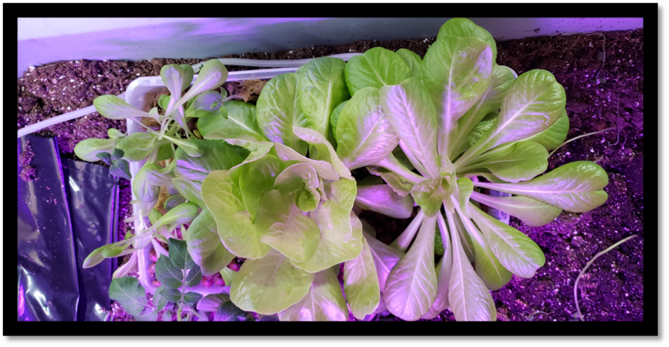
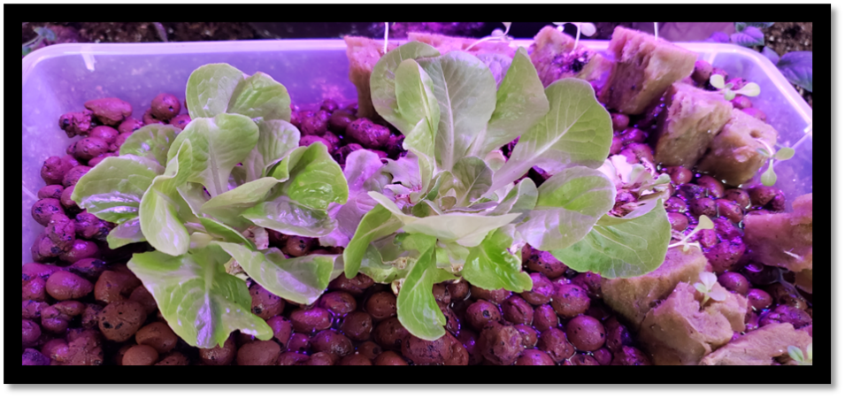
Instruction for making Micro Munch Unit
- Give each student a plastic shoe box. Have them write their group name on box with a sharpie.

- Place aquarium air stone in the bottom of the shoe box with attached airline tubing. Give enough airline to ensure air pump can be placed in a secure place. (One air pump can run 2 units with inline aquarium Y valve for 2.44M tubing)

- Fill shoe box with clay pebbles to one inch of the top of the shoe box.

- Place hydroponic net pot within the pebbles.

- Add microbe nutrient as instructed from manufacture for 1 gallon; add water solution to the top of the clay pebbles.

- Place rock wool cells on top of the clay pebbles along shoe box sidewall. Plant lettuce seed in each cell. As seen in the top photo. Allow to sprout (7-14 days)

- Hang LED light 4 inches above shoe box to allow lettuce to sprout; Adjust as needed.

- Once lettuce has set of 2 true leaves transfer to hydroponic nesting cubes and place in net pots. Add fertilizer per manufacture instructions for 1 gallon. Do not change water solution, add fertilizer and micronutrients as needed to keep water level near 1 inch from the top of the shoe box.

- Begin harvesting lettuce at proximity four weeks.

